**Kavya Reddy Nagulapally**

**700759486**

**Neural Networks - Assignment 1**

**GitHub link:** <https://github.com/Kavyareddy03/neural_networks>

1. **Full Name & String Alternative Programs**
   1. Write a program that takes two strings from the user: first_name, last_name. Pass these variables to the fullname function that should return the (full name).

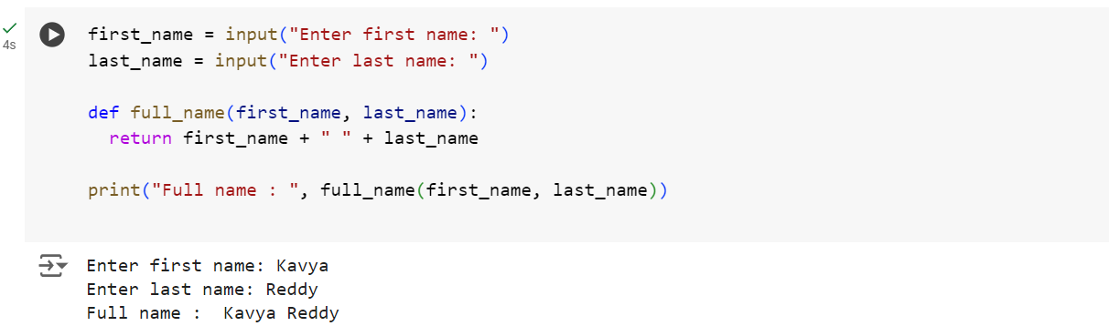

* 1. Write a function named “string_alternative” that returns every other char in the full_name string.

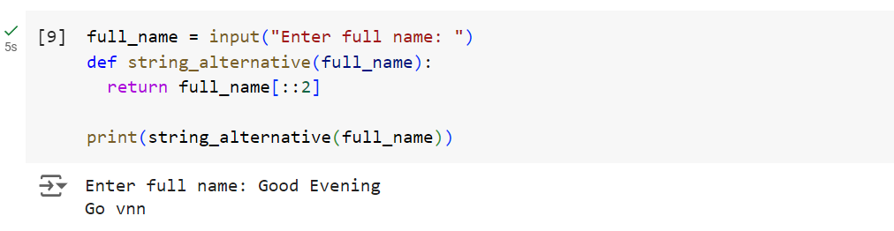

1. Write a python program to find the word count in a file (input.txt) for each line and then print the output. Finally store the output in the output.txt file.

**Input.txt file:**

Python Course

Deep Learning Course

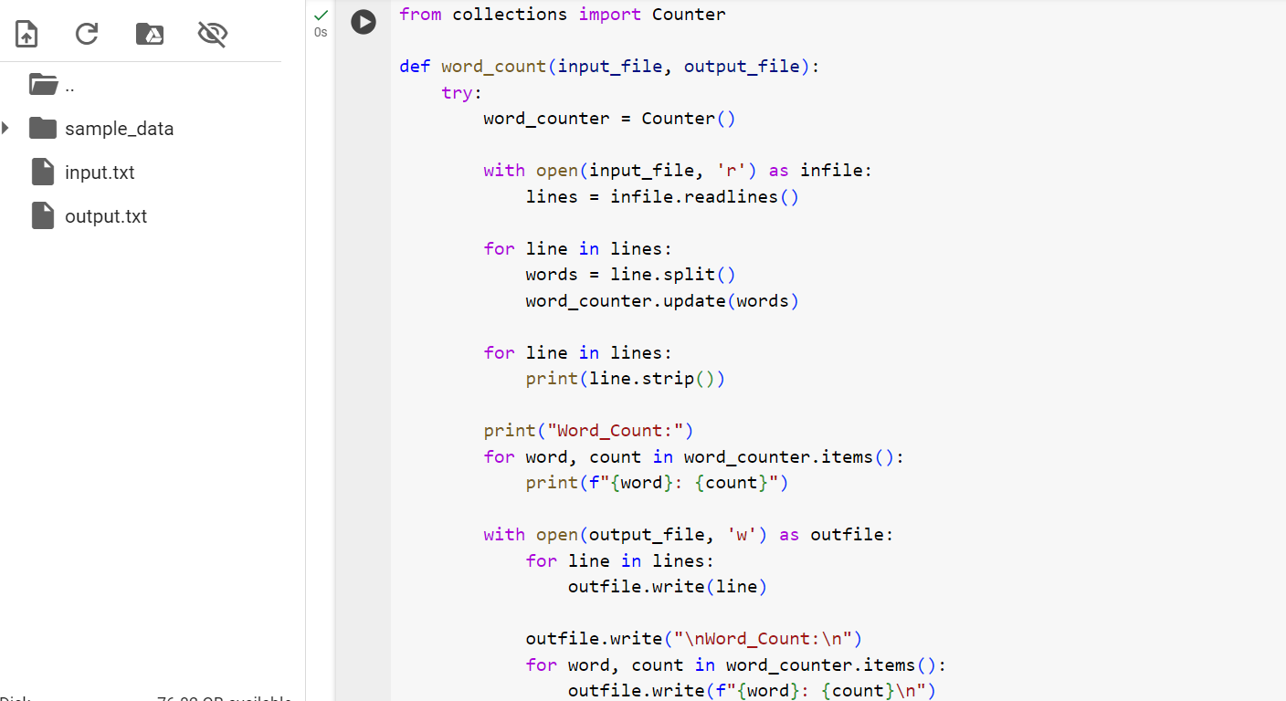

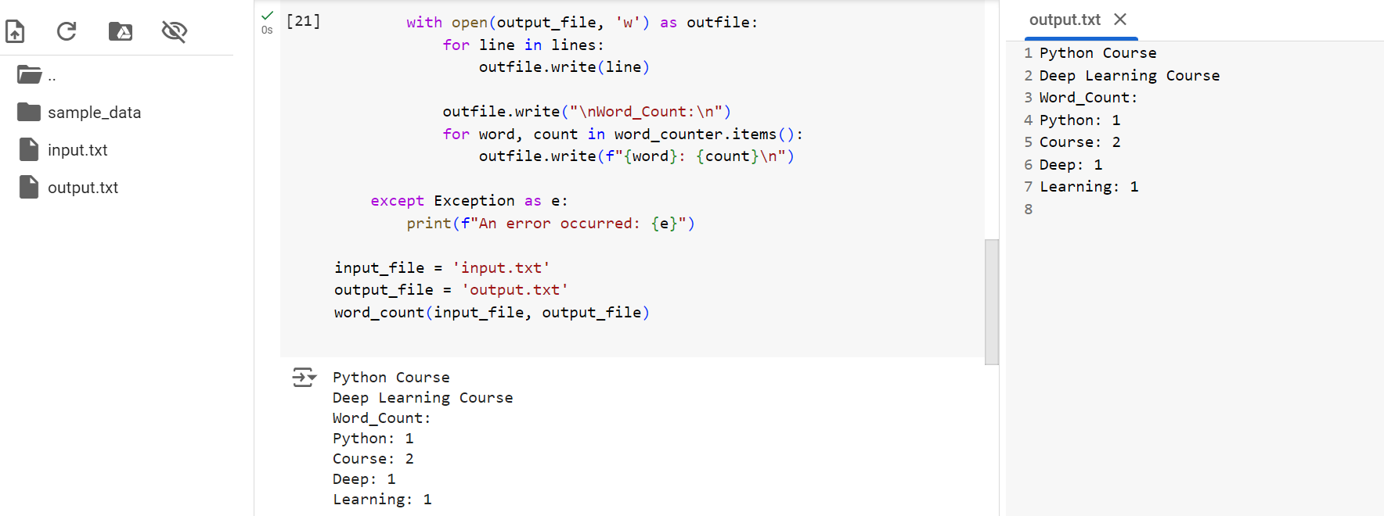

1. Write a program, which reads heights (inches.) of customers into a list and convert these heights to centimeters in a separate list using:
   1. Nested Interactive loop.
   2. List comprehensions

